# MALL SHOPPING



A

HCI Course Project Report

in partial fulfilment of the degree

**Bachelor of Technology**

in

**Computer Science & Engineering**

**By**

**BUDATI GAYATHRI 2303A51717**

Under the guidance of

**Bediga Sharan**

**Assistant Professor**

**Submitted to**

**School of Computer Science and Artificial Intelligence**



**DEPARTMENT OF COMPUTER SCIENCE & ENGINEERING**

**CERTIFICATE**

This is to certify that the **Human Computer Interface – Course Project** Report entitled **“MALL SHOPPING”** is a record of bonafide work carried out by the student **BUDATI GAYATHRI** bearing Hall Ticket No **2303A51717** during the academic year 2024-25 in partial fulfillment of the award of the degree of ***Bachelor of Technology*** in **Computer Science & Engineering** by the SR University, Warangal.

**Supervisor Head of the Department**

(Mr. Bediga Sharan) (Dr. M. Sheshikala)

Assistant Professor Professor

**ACKNOWLEDGMENT**

We owe an enormous debt of gratitude to our project guide **Mr. Bediga Sharan**, **Assistant Professor** as well as **Head of the CSE Department (HOD) Dr. M. Sheshikala**, **Professor** for guiding us from the beginning through the end of the Project with their intellectual advices and insightful suggestions. We truly value their consistent feedback on our progress, which was always constructive and encouraging and ultimately drove us to the right direction. We wish to take this opportunity to express our sincere gratitude and deep sense of respect to our beloved **Vice Chancellor, Prof. Deepak Garg**, for his continuous support and guidance to complete this project in the institute. Finally, we express our thanks to all the teaching and non-teaching staff of the department for their suggestions and timely support.

**TABLE OF CONTENT**

|  |  |
| --- | --- |
| **TOPIC** | **PAGE NO** |
| Abstract | 5 |
| Objective | 6 |
| Software and Hardware requirements | 7 |
| Elements Used | 8 |
| Design | 9-11 |
| Implementation | 12-22 |
| Result Screens | 23-25 |
| Conclusion | 26 |

**ABSTRACT**

By giving real-time information on neighbouring shopping malls and their current promotions, the Mall Shopping Project seeks to develop an intuitive platform that streamlines the shopping experience. The purpose of the page is to assist users in finding sales, discounts, and promotions in malls close to where they are now. The software finds the nearest retail locations by incorporating cutting-edge location-based services, which helps customers organise their trips effectively and save time.

With features like customisable search filters, navigation support, and notifications for special offers, the system guarantees a flawless user experience. Families or busy individuals who wish to make the most of their shopping excursions while taking advantage of affordable prices will find it ideal.

The Mall Shopping platform is a useful tool for consumers since it makes use of real-time data and contemporary online technology to improve customer comfort. This creative method helps neighbourhood malls efficiently reach their target clientele while simultaneously encouraging wiser buying.

**OBJECTIVE**

The main goal of this project is to develop a cutting-edge and intuitive web application that assists consumers in finding malls in their area that provide special offers and discounts. By saving customers time and effort while looking for the best deals at local malls, this page seeks to simplify the shopping experience.

Users of the site will be able to get real-time information on specials, promotions, and special events in nearby shopping malls, making it a one-stop shop. The platform will offer individualised suggestions based on the user's interests by incorporating location-based services, guaranteeing a quick and easy purchasing experience.

Additionally, by supporting neighbourhood companies and increasing traffic to participating malls, the strategy aims to close the gap between malls and consumers. To improve user convenience, it will have features including comprehensive retail directories, parking information, and navigation support.

This platform seeks to transform the conventional mall-shopping experience by saving users important time and assisting them in making well-informed purchasing decisions, making it more pleasurable and profitable for both consumers and companies.

**SOFTWARE AND HARDWARE REQUIREMENTS**

**SOFTWARE REQUIREMENTS:**

**TECHNICAL REQUIREMENTS:**

**>** HTML

**>** CSS

**>** JAVASCRIPT

**HARDWARE REQUIREMENTS:**

**Server:**

You'll need a robust server to host the mall shopping platform's database and application. The server should have sufficient processing power, memory, and storage capacity to handle the expected workload, ensuring smooth functionality and seamless user experiences as customers search for nearby shopping malls and offers.

**Database Server:**

A database server is essential to store and manage data related to shopping malls, offers, user information, and location-based services. It should have adequate storage and memory to ensure efficient data handling and quick access to information, enabling fast searches for nearby malls and deals.

**Network Infrastructure:**

Reliable networking equipment, including routers, switches, and a high-speed internet connection, is crucial to ensure smooth communication between various components of the mall shopping platform. This ensures seamless access for users and uninterrupted functionality, allowing customers to quickly find nearby shopping malls and current offers.

**ELEMENTS USED**

**1. Home:**The main landing page where users can quickly access key features, view promotions, and begin their search for nearby malls and offers. It provides an intuitive and user-friendly interface to guide users through the platform.

**2. Log In:**A secure login page where users can sign into their accounts to access personalized recommendations, saved malls, offers, and location preferences. It ensures that users have a tailored shopping experience**.**

**3. Location:**A section that prompts users to share their current location or enter a preferred location to find nearby malls and relevant offers. This feature helps the platform display location-specific results.

**4. Select Location:**Allows users to manually select their location from a list of cities, neighborhoods, or by using a map. This feature enhances flexibility, especially when users wish to search for malls in different areas.

**5. Malls:**A detailed listing of shopping malls in the selected area, showing names, addresses, and available offers. Users can browse through the options to find the best shopping experience near them.

**6. Map:**An interactive map that displays the exact locations of nearby malls. Users can view the proximity of malls to their current or selected location, helping them plan their trips more efficiently.

**7. About Us:**A section providing information about the platform, its purpose, and how it helps users find shopping malls and offers quickly and conveniently. It builds trust and explains the value of the service.

**8. Contact Us:**A contact page for users to reach out to the platform's support team for inquiries, feedback, or assistance. This feature ensures customers can easily get help when needed.

**9. Help:**A FAQ and support section that answers common questions and provides guidance on using the platform, such as how to find malls, navigate the map, or manage user profiles. This helps users resolve issues without needing to contact support directly.

**DESIGN**

SCREEN-1:

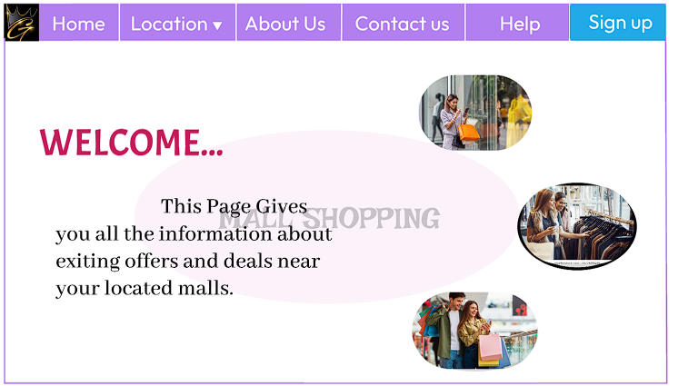

SCREEN-2:

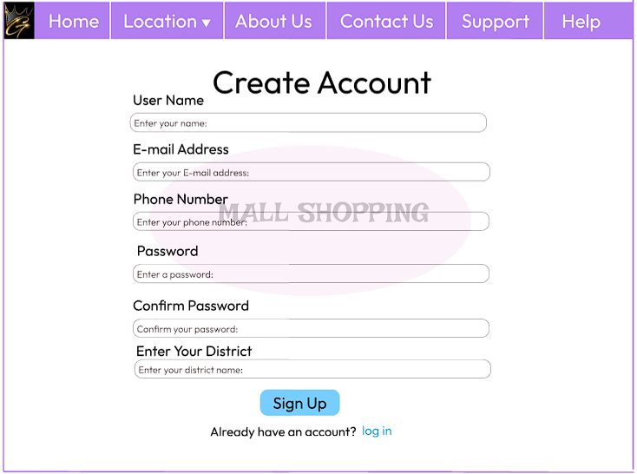

SCREEN-3:

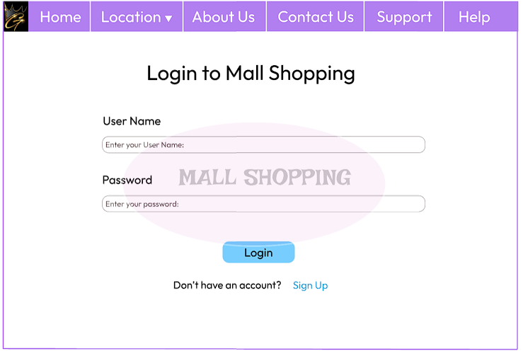

SCREEN-4:

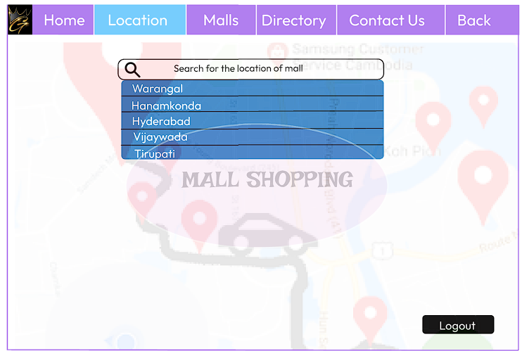

SCREEN-5:

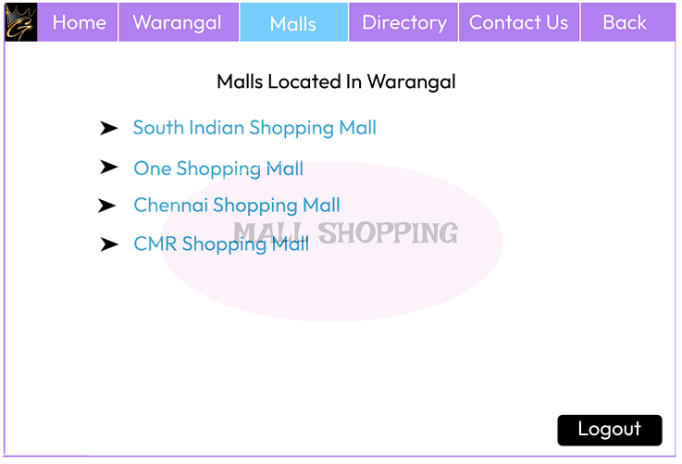

SCREEN-6:

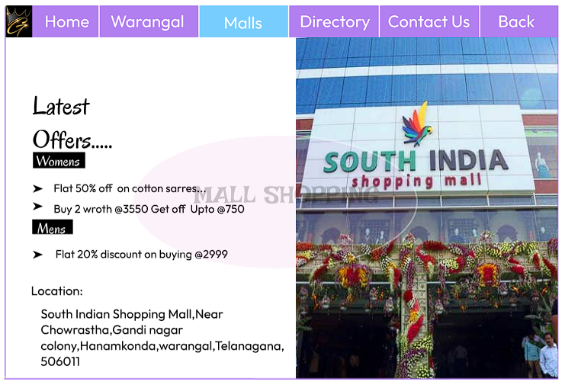

SCREEN-7:

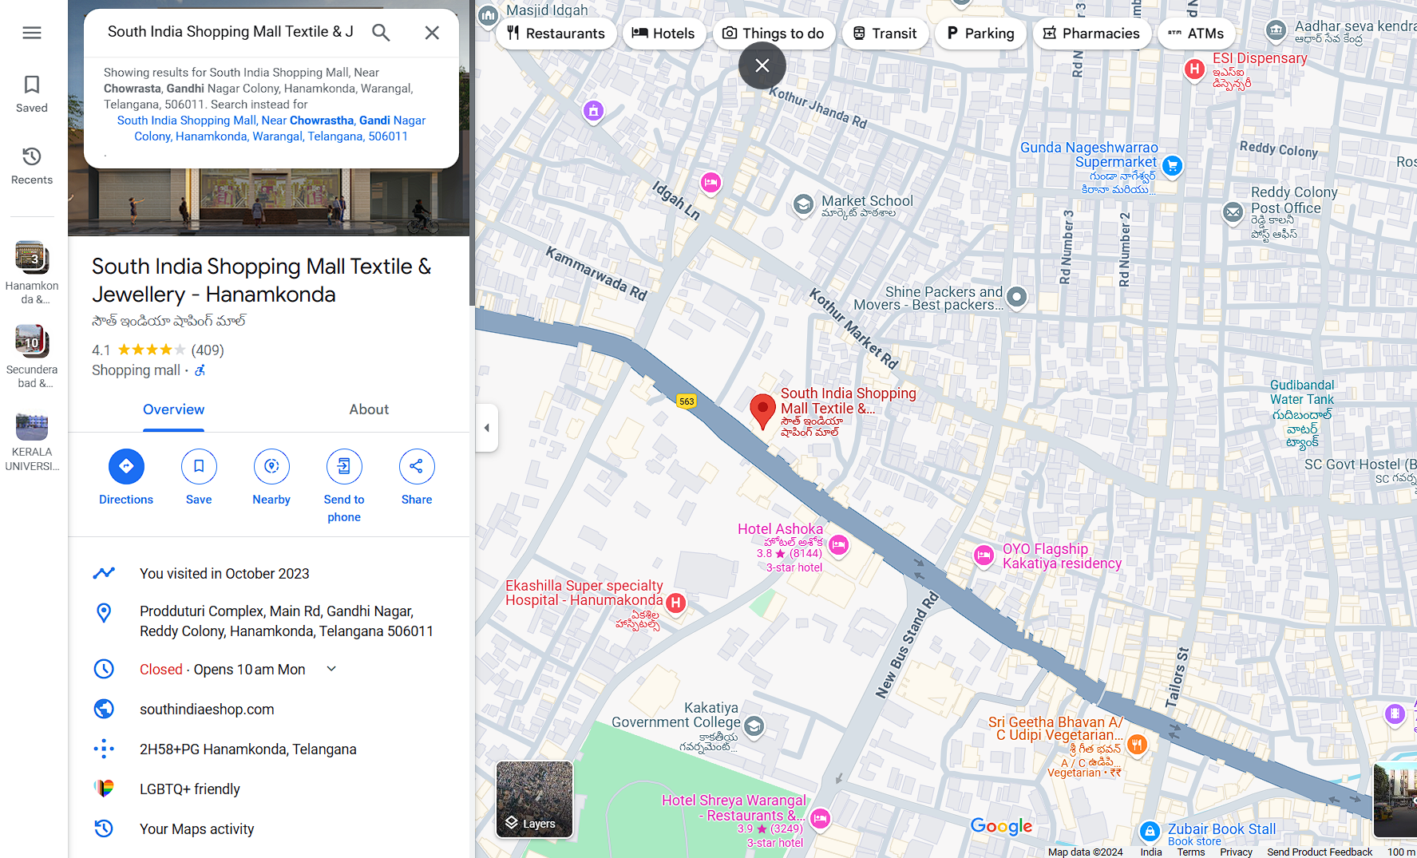

SCREEN-8:

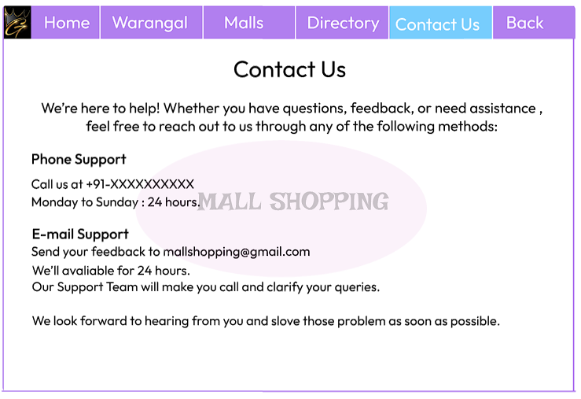

SCREEN-9:

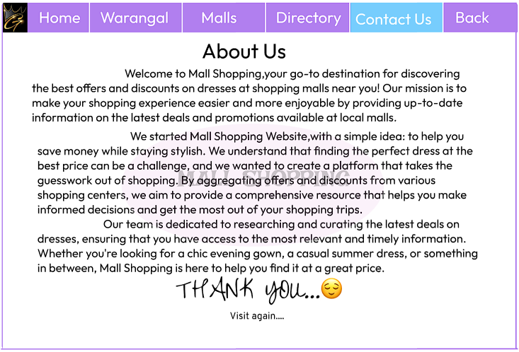

**IMPLEMENTATION**

CODE :

<!DOCTYPE html>

<html lang="en">

<head>

    <title>Mall Shopping Welcome Page</title>

    <style>

    body {

    font-family: 'Gill Sans', 'Gill Sans MT', Calibri, 'Trebuchet MS', sans-serif;

    background: url("Shoppimh.jpg");

    background-size: cover;

}

.navbar {

    background-color: #d9b3ff;

    display: flex;

    justify-content: space-around;

    padding: 10px 0;

}

.navbar a {

    text-decoration: none;

    color: black;

    font-weight: bold;

    padding: 8px 16px;

}

.navbar .home-button {

    border-radius: 8px;

    transition: background-color 0.5s ease, color 0.5s ease;

    padding: 8px 16px;

}

.navbar .home-button:hover {

    background-color: #77cdfd;

    color: white;

}

.navbar .aboutus-button {

    border-radius: 8px;

    transition: background-color 0.5s ease, color 0.5s ease;

    padding: 8px 16px;

}

.navbar .aboutus-button:hover {

    background-color: #77cdfd;

    color: white;

}

.navbar .contact-button {

    border-radius: 8px;

    transition: background-color 0.5s ease, color 0.5s ease;

    padding: 8px 16px;

}

.navbar .contact-button:hover {

    background-color: #77cdfd;

    color: white;

}

.navbar .help-button {

    border-radius: 8px;

    transition: background-color 0.5s ease, color 0.5s ease;

    padding: 8px 16px;

}

.navbar .help-button:hover {

    background-color: #77cdfd;

    color: white;

}

.navbar .signup-button {

    border-radius: 8px;

    transition: background-color 0.5s ease, color 0.5s ease;

    padding: 8px 16px;

}

.navbar .signup-button:hover {

    background-color: #77cdfd;

    color: white;

}

.navbar .logo {

    width: 30px;

    margin-right: 20px;

}

.content {

    display: flex;

    justify-content: space-between;

    align-items: center;

    margin: 50px auto;

    padding: 20px;

    width: 80%;

    background-color: #ffffff;

    border: 1px solid #e0e0e0;

    border-radius: 10px;

}

.welcome-text {

    max-width: 50%;

    text-align: left;

}

.welcome-text h1 {

    color: #cc0066;

    font-size: 36px;

    margin-bottom: 10px;

}

.welcome-text p {

    font-size: 18px;

    line-height: 1.5;

}

.images-container {

    display: flex;

    flex-direction: column;

    align-items: flex-end;

    gap: 15px;

}

.shopping-image {

    width: 250px;

    height: auto;

    border-radius: 50px;

}

.footer {

            position: absolute;

            bottom: 0;

            width: 90%;

            text-align: center;

            background-color: none;

            padding: 10px;

            font-size: 14px;

      }

.fa {

            padding: 20px;

            font-size: 30px;

            width: 50px;

            text-align: center;

            text-decoration: none;

       }

       .fa:hover {

           opacity: 0.7;

       }

       .fa-facebook {

           background: #3B5998;

           color: white;

       }

       .fa-twitter {

           background: #55ACEE;

           color: white;

      }

   </style>

</head>

<body>

    <div class="navbar">

    <img src="G LETTERS MALL.JPG" alt="Logo" class="logo">

        <a href="mall.html" class="home-button">Home</a>

        <a href="aboutus.html" class="aboutus-button">About Us</a>

        <a href="contact.html" class="contact-button">Contact us</a>

        <a href="help.html" class="help-button">Help</a>

        <a href="signup.html" class="signup-button">Sign up</a>

    </div>

    <div class="content">

        <div class="welcome-text">

            <h1>MALL SHOPPING</h1>

            <h2>WELCOME...</h2>

            <p>This Page Gives you all the information about exiting offers and deals near your located malls.</p>

        </div>

        <div class="images-container">

            <img src="mall.3.jpg" alt="Shopping Image 1" class="shopping-image">

            <img src="mall.4.jpg" alt

            ="Shopping Image 2" class="shopping-image">

            <img src="mall.5.jpg" alt="Shopping Image 3" class="shopping-image">

        </div>

    </div>

<div class="footer">

        <h3>Copyright ©2024 @Mall Shopping</h3>

        <link rel="stylesheet" href="https://cdnjs.cloudflare.com/ajax/libs/font-awesome/4.7.0/css/font-awesome.min.css">

    <a href="#" class="fa fa-facebook"></a>

    <a href="#" class="fa fa-twitter"></a>

   </div>

</body>

</html>

CODE :

<!DOCTYPE html>

<html lang="en">

<head>

    <title>Location</title>

    <style>

    body {

    font-family: 'Gill Sans', 'Gill Sans MT', Calibri, 'Trebuchet MS', sans-serif;

    background: url("Shoppimh.jpg");

    background-size: cover;

}

.container {

    width: 100%;

    max-width: 1024px;

    margin: 0 auto;

    background-color: #e7e4fc;

    padding: 20px;

    border: 1px solid #ccc;

    position: relative;

}

.navbar {

    background-color: #d9b3ff;

    display: flex;

    justify-content: space-around;

    padding: 10px 0;

}

.navbar a {

    text-decoration: none;

    color: black;

    font-weight: bold;

    padding: 8px 16px;

}

.navbar .logo {

    width: 30px;

    margin-right: 20px;

}

.navbar .home-button {

    border-radius: 8px;

    transition: background-color 0.5s ease, color 0.5s ease;

    padding: 8px 16px;

}

.navbar .home-button:hover {

    background-color: #77cdfd;

    color: white;

}

.navbar .location-button {

    border-radius: 8px;

    transition: background-color 0.5s ease, color 0.5s ease;

    padding: 8px 16px;

}

.navbar .location-button:hover {

    background-color: #77cdfd;

    color: white;

}

.navbar .aboutus-button {

    border-radius: 8px;

    transition: background-color 0.5s ease, color 0.5s ease;

    padding: 8px 16px;

}

.navbar .aboutus-button:hover {

    background-color: #77cdfd;

    color: white;

}

.navbar .contact-button {

    border-radius: 8px;

    transition: background-color 0.5s ease, color 0.5s ease;

    padding: 8px 16px;

}

.navbar .contact-button:hover {

    background-color: #77cdfd;

    color: white;

}

.navbar .help-button {

    border-radius: 8px;

    transition: background-color 0.5s ease, color 0.5s ease;

    padding: 8px 16px;

}

.navbar .help-button:hover {

    background-color: #77cdfd;

    color: white;

}

.navbar .logout-button {

    border-radius: 8px;

    transition: background-color 0.5s ease, color 0.5s ease;

    padding: 8px 16px;

}

.navbar .logout-button:hover {

    background-color: #77cdfd;

    color: white;

}

.location-select {

    width: 500px;

    font-size:50px;

    padding: 5px;

    max-height: 300px;

    overflow-y: auto;

}

.location-select option {

    font-size: 18px;

    padding: 10px;

}

.search-section {

    margin: 20px 0;

    position: relative;

    text-align: center;

    font-size:50px;

    color:white;

}

.search-bar {

    width: 50%;

    padding: 10px;

    border-radius: 100px;

    border: 1px solid #ccc;

}

.select{

    position:center;

    border-radius:200px;

}

.dropdown {

    position: absolute;

    top: 60px;

    left: 50%;

    transform: translateX(-50%);

    background-color: #4b87e6;

    width: 50%;

    border-radius: 5px;

    color: white;

}

.dropdown ul {

    list-style: none;

    padding: 10px;

    margin: 0;

}

.dropdown ul li {

    padding: 8px 10px;

    cursor: pointer;

}

.dropdown ul li:hover {

    background-color: #6fa3f7;

}

footer {

    text-align:center;

    margin-top: 40px;

}

.logout-btn {

    padding: 8px 15px;

    background-color: none;

    color: white;

    border: none;

    border-radius: 5px;

    cursor: pointer;

}

.logout-btn:hover {

    background-color: #333;

}

.footer {

            position: absolute;

            bottom: 0;

            width: 90%;

            text-align: center;

            background-color: none;

            padding: 10px;

            font-size: 14px;

      }

.fa {

            padding: 20px;

            font-size: 30px;

            width: 50px;

            text-align: center;

            text-decoration: none;

       }

       .fa:hover {

           opacity: 0.7;

       }

       .fa-facebook {

           background: #3B5998;

           color: white;

       }

       .fa-twitter {

           background: #55ACEE;

           color: white;

      }

</style>

</head>

<body>

    <div class="navbar">

        <img src="G LETTERS MALL.JPG" alt="Logo" class="logo">

        <a href="mall.html" class="home-button">Home</a>

        <a href="location.html" class="location-button">Location</a>

        <a href="aboutus.html" class="aboutus-button">About Us</a>

        <a href="contact.html" class="contact-button">Contact us</a>

        <a href="help.html" class="help-button">Help</a>

        <a href="mall.html" class="logout-button">Logout</a>

    </div>

    <div class="search-section">

        <label for="mall-location" class="search-label">Search for your location</label><br>

        <select id="mall-location" class="location-select" onchange="navigateToLocation()">

            <option value="" disabled selected>Select location</option>

            <option value="warangal.html">Warangal</option>

            <option value="hanamkonda.html">Hanamkonda</option>

            <option value="hyderabad.html">Hyderabad</option>

            <option value="vijayawada.html">Vijayawada</option>

            <option value="tirupati.html">Tirupati</option>

            <option value="khammam.html">Khammam</option>

            <option value="vizag.html">Vizag</option>

            <option value="vishakapatnam.html">Vishakapatnam</option>

        </select>

    </div>

    <script>

        function navigateToLocation() {

            const selectedLocation = document.getElementById('mall-location').value;

            if (selectedLocation) {

                window.location.href = selectedLocation;

            }

        }

    </script>

    <div class="footer">

        <p>Copyright ©2024 @Mall Shopping</p>

        <link rel="stylesheet" href="https://cdnjs.cloudflare.com/ajax/libs/font-awesome/4.7.0/css/font-awesome.min.css">

    <a href="#" class="fa fa-facebook"></a>

    <a href="#" class="fa fa-twitter"></a>

   </div>

</body>

</html>

<!DOCTYPE html>

<html lang="en">

<head>

    <title>Mall Shopping</title>

    <style>

    body {

    font-family: 'Gill Sans', 'Gill Sans MT', Calibri, 'Trebuchet MS', sans-serif;

    background: url("Shoppimh.jpg");

    background-size: cover;

}

.navbar {

  background-color: #d9b3ff;

  display: flex;

  justify-content: space-around;

  padding: 10px 0;

}

.navbar a {

    text-decoration: none;

    color: black;

    font-weight: bold;

    padding: 8px 16px;

}

.navbar .logo {

  width: 30px;

  margin-right:20px;

}

.navbar .home-button {

    border-radius: 8px;

    transition: background-color 0.5s ease, color 0.5s ease;

    padding: 8px 16px;

}

.navbar .home-button:hover {

    background-color: #77cdfd;

    color: white;

}

.navbar .location-button {

    border-radius: 8px;

    transition: background-color 0.5s ease, color 0.5s ease;

    padding: 8px 16px;

}

.navbar .location-button:hover {

    background-color: #77cdfd;

    color: white;

}

.navbar .menu-button {

    border-radius: 8px;

    transition: background-color 0.5s ease, color 0.5s ease;

    padding: 8px 16px;

}

.navbar .menu-button:hover {

    background-color: #77cdfd;

    color: white;

}

.navbar .contact-button {

    border-radius: 8px;

    transition: background-color 0.5s ease, color 0.5s ease;

    padding: 8px 16px;

}

.navbar .contact-button:hover {

    background-color: #77cdfd;

    color: white;

}

.navbar .back-button {

    border-radius: 8px;

    transition: background-color 0.5s ease, color 0.5s ease;

    padding: 8px 16px;

}

.navbar .back-button:hover {

    background-color: #77cdfd;

    color: white;

}

.navbar .logout-button {

    border-radius: 8px;

    transition: background-color 0.5s ease, color 0.5s ease;

    padding: 8px 16px;

}

.navbar .logout-button:hover {

    background-color: #77cdfd;

    color: white;

}

.navbar .logo {

    width: 30px;

    height: 20px;

}

.content {

    background-color: #fff;

    padding: 50px;

    border: 2px solid #e8d7fc;

    width: 93%;

    text-align: center;

    font-size:30px;

    position: relative;

    margin: 20px 0;

}

.content h2 {

    font-size: 40px;

    color: #000;

}

.mall-list {

    list-style: none;

    padding: 0;

}

.mall-list li {

    margin: 10px 0;

    font-size: 18px;

}

.mall-list li .arrow {

    color: #333;

    margin-right: 10px;

}

.mall-list a {

    color: #5bc0de;

    text-decoration: none;

}

.mall-list a:hover {

    text-decoration: underline;

}

.logout-button {

    padding: 8px 15px;

    background-color: none;

    color: white;

    border: none;

    border-radius: 5px;

    cursor: pointer;

}

.logout-button:hover {

    background-color: #333;

}

.footer {

            position: absolute;

            bottom: 0;

            width: 90%;

            text-align: center;

            background-color: none;

            padding: 10px;

            font-size: 14px;

      }

.fa {

            padding: 20px;

            font-size: 30px;

            width: 50px;

            text-align: center;

            text-decoration: none;

       }

       .fa:hover {

           opacity: 0.7;

       }

       .fa-facebook {

           background: #3B5998;

           color: white;

       }

       .fa-twitter {

           background: #55ACEE;

           color: white;

      }

</style>

</head>

<body>

    <div class="navbar">

        <img src="G LETTERS MALL.JPG" alt="Logo" class="logo">

        <a href="mall.html" class="home-button">Home</a>

        <a href="location.html" class="location-button">Warangal</a>

        <a href="menu.html" class="menu-button">Malls</a>

        <a href="contact.html" class="contact-button">Contact Us</a>

        <a href="location.html" class="back-button">Back</a>

        <a href="mall.html" class="logout-button">Logout</a>

    </div>

    <div class="content">

        <h2>Malls Located In Warangal</h2>

        <div class="mall-list">

            <span class="arrow">&#9658;</span> <a href="southmall.html">South Indian Shopping Mall</a><br></br>

            <span class="arrow">&#9658;</span> <a href="onemall.html">One Shopping Mall</a><br></br>

            <span class="arrow">&#9658;</span> <a href="chennai.html">Chennai Shopping Mall</a><br></br>

            <span class="arrow">&#9658;</span> <a href="cmr.html">CMR Shopping Mall</a><br></br>

        </div>

    </div>

       <div class="footer">

        <p>Copyright ©2024 @Mall Shopping</p>

        <link rel="stylesheet" href="https://cdnjs.cloudflare.com/ajax/libs/font-awesome/4.7.0/css/font-awesome.min.css">

    <a href="#" class="fa fa-facebook"></a>

    <a href="#" class="fa fa-twitter"></a>

   </div>

</body>

</html>

**RESULT SCREEN**

HOME PAGE

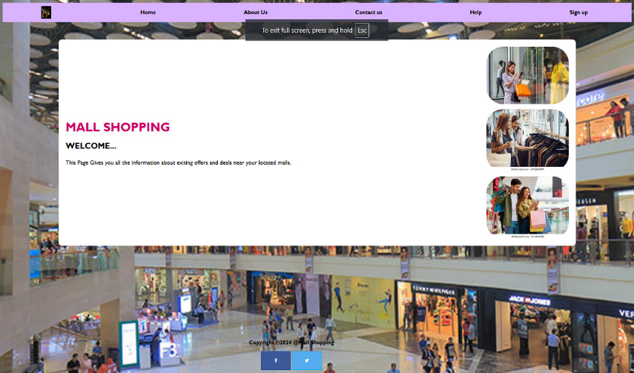

LOCATION SELECT PAGE

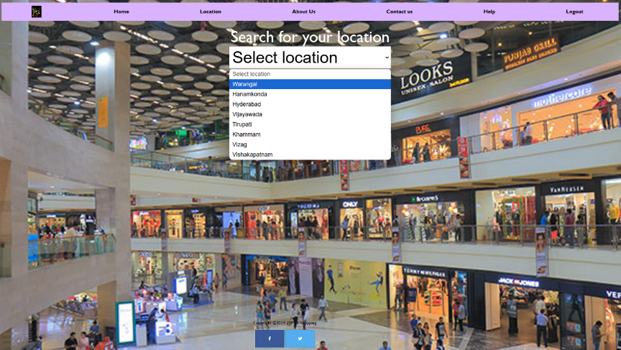

USER LOCATION PAGE

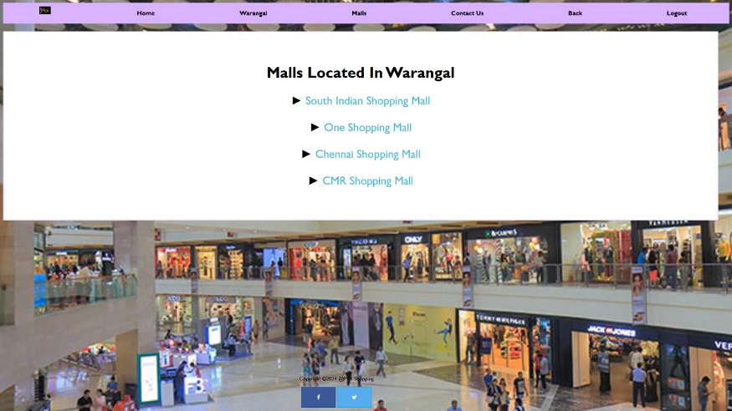

USER SELECTED MALL PAGE

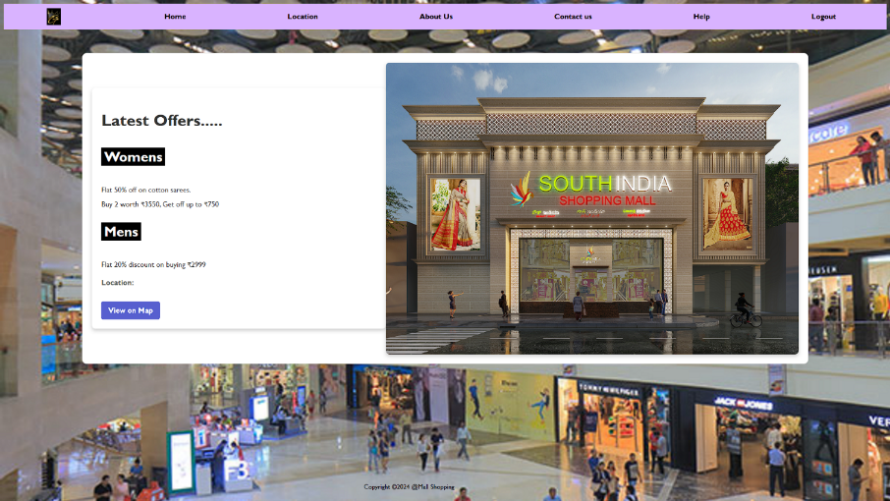

MALL LOCATION

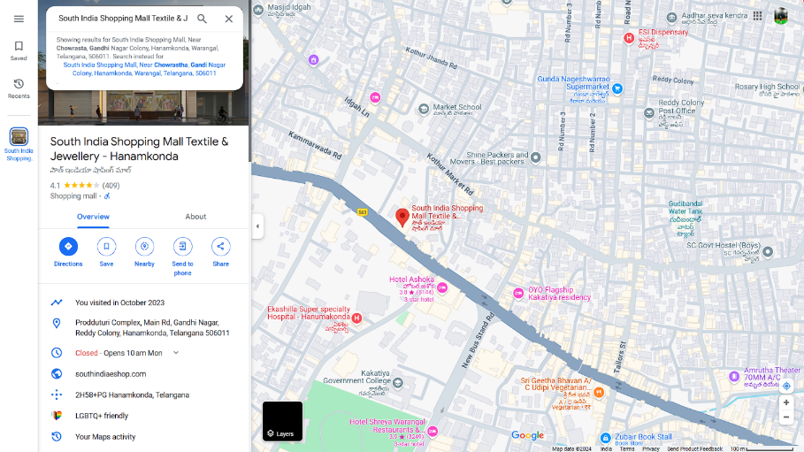

ABOUT US

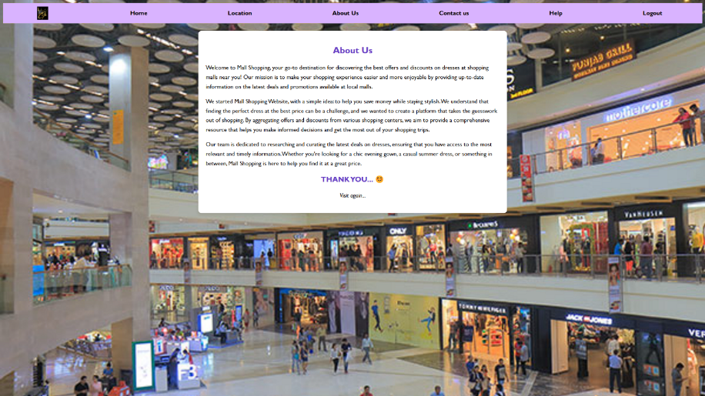

CONTACT PAGE

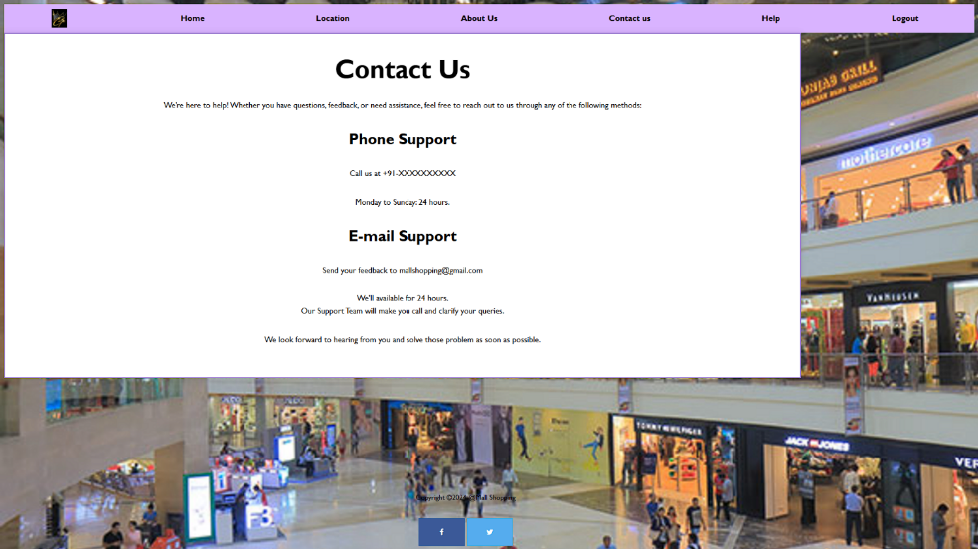

**CONCLUSION**

The **Mall Shopping Project** offers a revolutionary way for users to discover nearby shopping malls and explore current offers, all from the convenience of their smartphones or computers. By integrating location-based services, this platform allows customers to quickly find malls within their vicinity, reducing the time and effort spent searching for deals. In today’s fast-paced world, time is a valuable resource, and this project aims to maximize efficiency by providing a one-stop solution for all shopping needs.

With features such as real-time location detection, mall listings, and an interactive map, the platform ensures that users can easily find the best shopping options without the hassle of long drives or endless searching. The “Select Location” feature further empowers users to plan their trips according to their preferences, whether they are looking for a mall in their current area or a different location.

Additionally, the integration of special offers and promotions within the platform adds value by highlighting exclusive deals that shoppers can take advantage of while exploring various malls. This creates a more personalized and rewarding shopping experience.

Overall, the Mall Shopping Project is designed to streamline the shopping process, save time, and make mall visits more convenient for families, friends, and solo shoppers alike. By providing a comprehensive, user-friendly platform with relevant mall information and offers, it significantly enhances the shopping experience, helping users make the most of their time and budget.